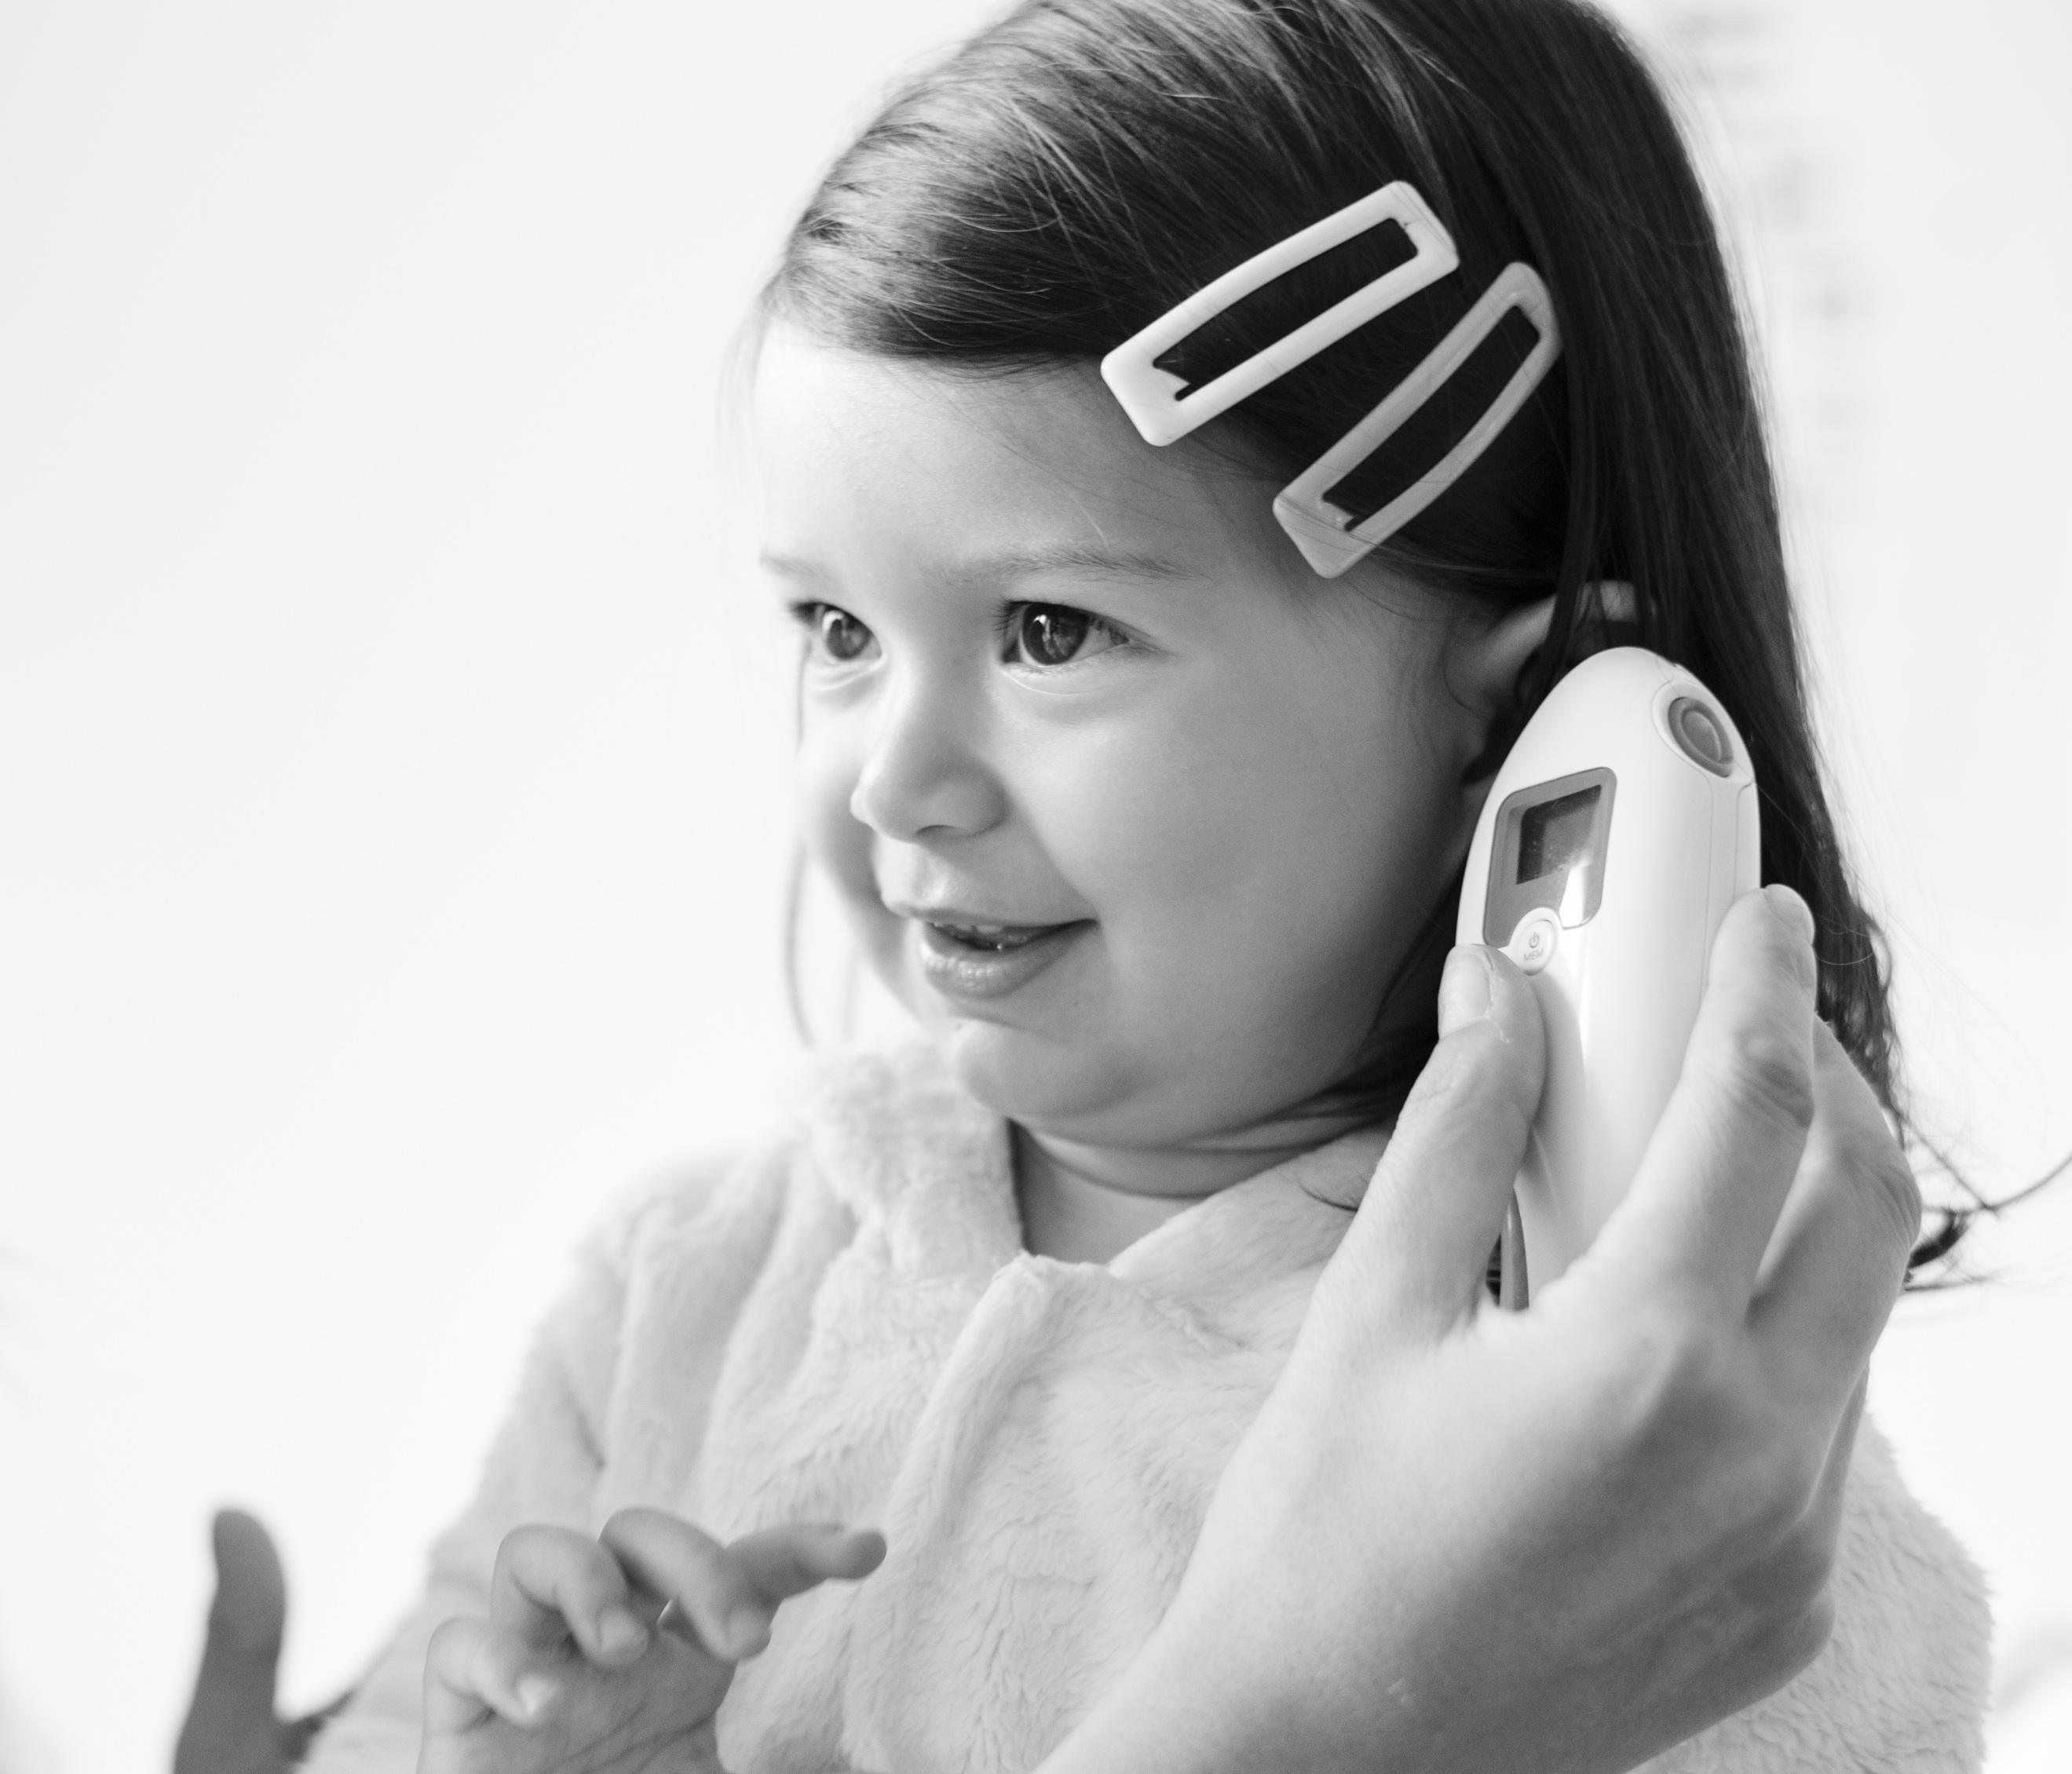



Follow me to page to learn more about what to expect on the day of surgery.

**Inside**

What to do prior to surgery

Resources for parents

Acknowledgements

**Perioperative Toolkit**

**for Parents of Children with**

**Autism or Special Needs**

## **A Guide for Parents:**

## **How to Better Prepare**

## **your Child for their Upcoming Surgery**

### “Children on the spectrum have a high need to control their environment, and advanced preparation can help ease their anxiety.”

### – A parent on the Family Advisory Council

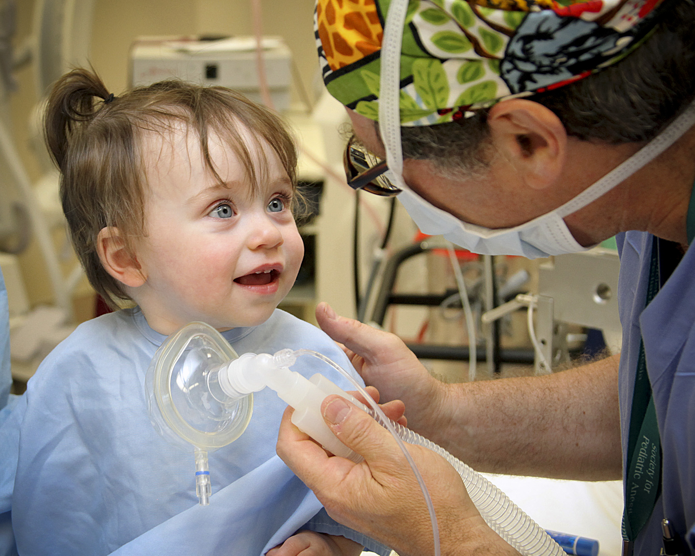

***Surgery can be uncomfortable and frightening for any child, but especially for children living with autism or special needs.*** The new environment, bright lights, loud noises, unfamiliar textures, and the interactions with new people can be stressful and overpowering.

As a result, children living with autism or special needs may have difficulty self-regulating when feeling overwhelmed. To better serve these children, this toolkit is designed to help you and your child have a more comfortable and successful visit at UCSF Benioff Children’s Hospital Oakland.

**♦ *My Hospital Passport***

The *My Hospital Passport* is a simple, two-page form that alerts the health care staff to important things like how your child deals with communication, stress, and pain. Filling this out beforehand and sharing it with the health care team helps them learn how to best care for your child.

**♦ *Social Story***

The *Team Beni Social Story* comes in two formats: a video and a coloring book. It is designed to give your child a preview of what to expect on the day of surgery, from start to finish. We highly recommend you watch the video with your child prior to surgery day. The video can be viewed online at **https://youtu.be/-4XZ1tTH8Bs**.

**♦ *Virtual Reality***

Virtual reality can make waiting for surgery more fun and less stressful. Be sure to speak with the pre-operative nurse about it on the day of surgery!

**What to do**

**prior to surgery:**

**♦ *Pre-Anesthesia Clinic***

The purpose of the Pre-Anesthesia Clinic is to make sure your child is well enough to undergo surgery; it is also an opportunity for you to ask questions and learn how to prepare your child for the day of surgery. You and your child will meet with a nurse practitioner who will do a physical check-up and ask a series of questions about your child’s medications and health history.

Because we want to create a personalized care plan for your child, please alert the nurse practitioner to any special requests or accommodations. For example, you can ask for a ***tour of the perioperative area***, obtain a set of ***hospital pajamas*** for your child to take home and wear on surgery day, or request ***virtual reality*** to be used as your child is awaiting surgery.

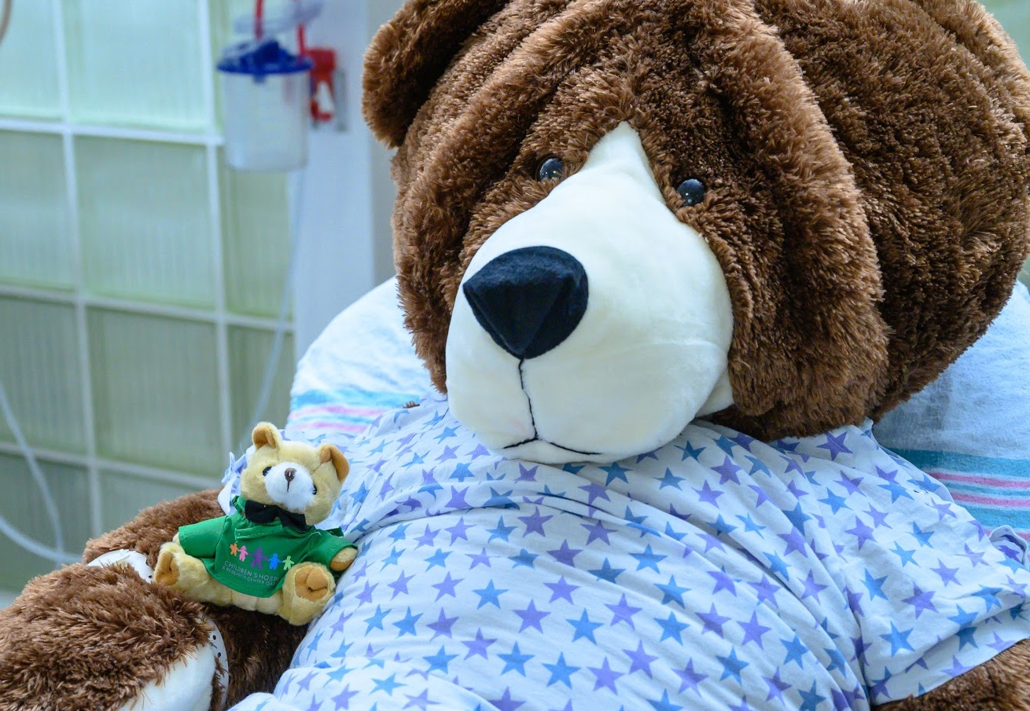

Bring a few of your child’s favorite things (e.g., iPad, favorite stuffed animal, blanket, etc.) to keep them comfortable.

Do not bring other children to the hospital on the day of surgery, if possible.

Consider bringing a new toy or item which can be used as a reward to help motivate your child.

If you have not already, be sure to watch the ***social* *story video*** with your child prior to surgery: **https://**

**youtu.be/-4XZ1tTH8Bs**

**Last Minute Reminders:**

**What to expect** on

the **day of surgery:**

* In the outpatient building lobby, walk straight from the front desk and take the elevators on your left up to the 3rd floor.
* Register with the clerk at the Surgery Registration window.
* Wait to be called by a pre-operative nurse to be taken to the pre-operative area. ***The role of the pre-operative nurse is to receive and prepare the patient for surgery.***
* To make your child more comfortable as they await surgery, you can ask the pre-operative nurse about using virtual reality!
* In the pre-operative area, you will meet with your child’s doctor, the operative room nurses, and the anesthesiologist. Each provider will ask you a series of questions to ensure safe and effective care.
* If necessary, the child life specialist may be involved in your child’s care. ***The role of the child life specialist is to assist with preparing patients for medical procedures by using age-specific tools and utilizing strategies such as imagery, distraction, and relaxation to reduce anxiety associated with surgery or hospitalization.***
* After surgery, a staff member will notify you when your child is finished with surgery. Your child will be transferred to the post anesthesia care unit (PACU), also referred to as the recovery room, where the PACU nurse will care for them. ***The role of the PACU nurse is to help your child as they wake up from anesthesia.***
* Because we want to make sure your child is completely healthy before going home, your doctor may ask your child to stay overnight so we can monitor their recovery.

***After surgery, your child may still be asleep or may be disoriented due to anesthesia. Make sure to have their favorite items to greet them with!***

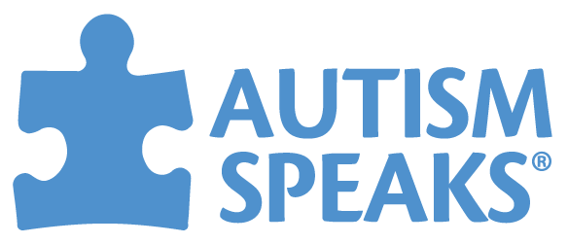

**Resources for Parents**

Below we have compiled a list of resources you may find helpful while caring for your child.

**Alameda County Developmental Disabilities Council** (http://www.acphd.org/ddc.aspx)

* Division of the Alameda County Public Health Department
* Let your voice be heard! Council meetings are typically held on the second Wednesday of the month from 9:30am-12:00pm. Call 1-510-267-3261 to confirm the time and place.

**Autism Society San Francisco Bay Area** (https://www.sfautismsociety.org/)

* This is a grassroots nonprofit run by volunteers who want to support the SF Bay Area autism community. Activities include information-sharing, networking, education, and advocacy.
* Call 1-650-637-7772 or e-mail info@sfautismsociety.org.

**Autism Speaks** (https://www.autismspeaks.org)

* Extensive list of resources for individuals with ASD and their families or caregivers
* Toolkits: *A Parent’s Guide to Autism* • *100 Day Kit for Newly Diagnosed Families (of Young Children; of School Age Children)* • *Challenging Behaviors Tool Kit*
* Autism Response Team (ART) provides information, support, and assistance.
  + 1-888-AUTISM2 (1-888-288-4762) • En Español: 1-888-772-9050
  + E-mail: familyservices@autismspeaks.org

**Autism Spectrum Therapies (AST)** (https://autismtherapies.com)

* AST utilizes Applied Behavior Analysis (ABA) in the home and at school to help children with autism reach their full potential.
* See the Parent Resources section of their website for helpful blogs, videos, and podcasts.
* Services are offered in the Bay Area: https://autismtherapies.com/locations/bayarea/
* Regional Center of the East Bay (see below) is an in-network insurance provider.
* 1-866-727-8274 • Local office: 6601 Owens Drive, Suite 270, Pleasanton, CA 94588

**Autistic Self Advocacy Network (ASAN)** (https://autisticadvocacy.org/)

* This is a national grassroots nonprofit created to promote the voices and advance the rights of persons living with autism through public policy and education.
* Click on the Resources tab on their website for helpful educational materials.

**CalFresh Food** (https://calfresh.dss.ca.gov/food/)

* California’s food stamps program. SSI recipients are eligible to apply.
* Apply: 1-877-847-3663(FOOD), online (https://getcalfresh.org), or visit your local office.

**Family Resource Navigators** (https://familyresourcenavigators.org/)

* Local nonprofit serving families of children with disabilities living in Alameda County
* Call 1-510-547-7322 or e-mail info@familyresourcenavigators.org.
* Office location: 291 Estudillo Avenue, San Leandro, CA 94577

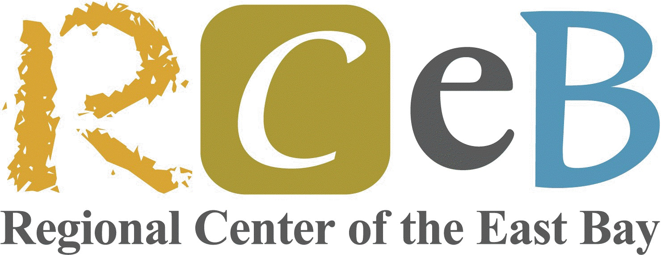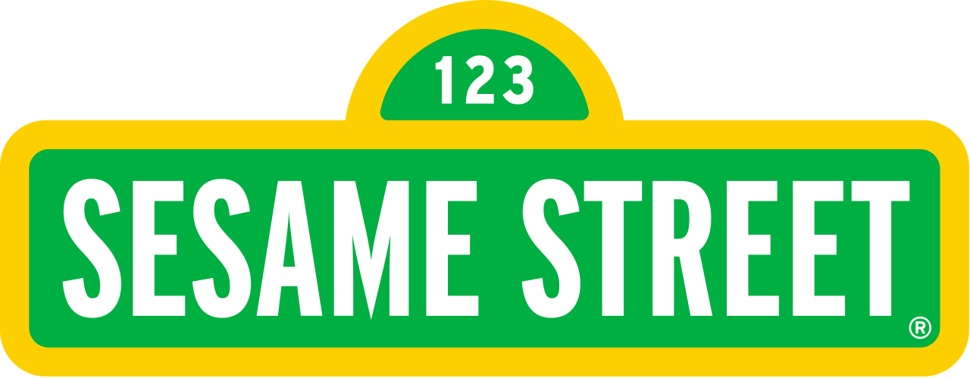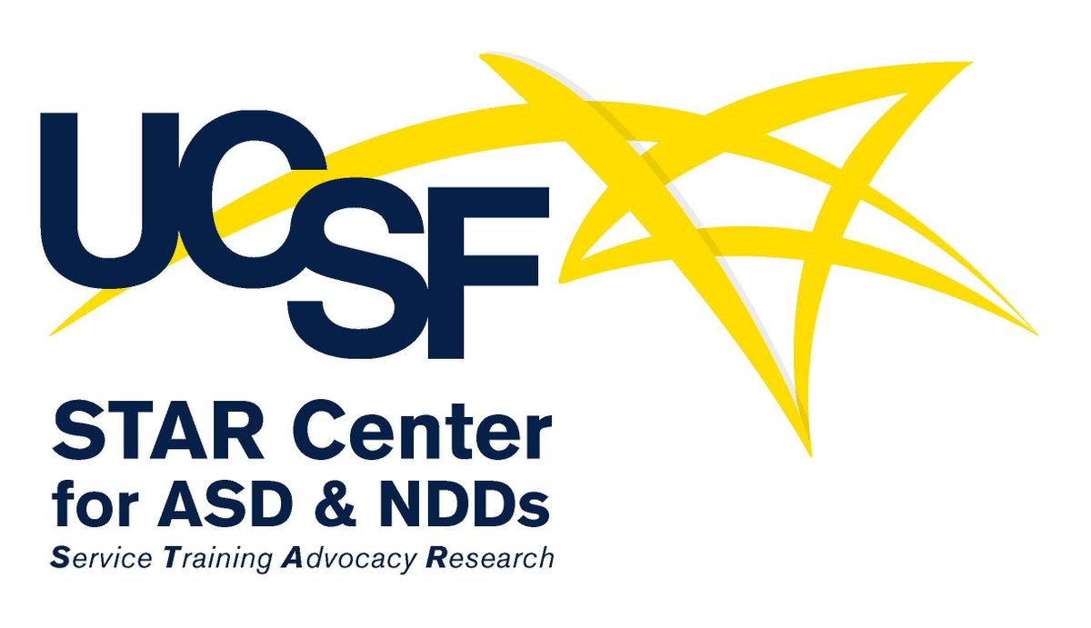

**Resources for Parents**

**Continued**

**Juvo Autism and Behavioral Health Services** (https://www.juvobh.com)

* Juvo uses Applied Behavior Analysis (ABA) to provide in-home and school behavioral health services for children with autism and other special needs. They also run camp programs, provide resources, and can support you in meeting your child’s individual needs.
* Call 1-510-832-4383, visit the website, or e-mail info@juvobh.com for more information.

**Medi-Cal** (https://www.coveredca.com/medi-cal/)

* Did you know that persons with disabilities are eligible for Medi-Cal?
* Apply online (http://www.coveredca.com/apply/), by phone (1-800-300-1506), or at your local office (the Alameda County office is located at 24100 Amador St., Hayward, CA 94544).

**National Autism Center** (https://nationalautismcenter.org)

* Free toolkit: *A Parent’s Guide to Evidence-based Practice and Autism* (see the Resources tab)

**National Autism Resources** (https://www.nationalautismresources.com)

* Founded by a mother of a child with autism, National Autism Resources sells products (for home, school, etc.) to assist children living with autism.
* Shop online or call 1-877-249-2393 for more information.

**Regional Center of the East Bay (RCEB)** (http://rceb.org/)

* RCEB was established as a result of the Lanterman Developmental Disabilities Act (AB 846) and is part of a network of 21 non-profit regional centers which provide lifelong services to persons with developmental disabilities.
* To apply for services:
  + Birth to age 3: Call 1-510-618-6195 or e-mail earlystartreferrals@rceb.org.
  + Age 3 and over: Call 1-510-618-6122 or e-mail intakeoverthree@rceb.org.

**Sesame Street** (https://autism.sesamestreet.org)

* Storybooks, videos, and interactive activities for your child
* Short informational articles and videos for parents
* Additional resources: https://sesamestreetincommunities.org/topics/autism

**UCSF STAR Center for ASD & NDDs** (https://star.ucsf.edu)

* *First Steps*, a group for parents of children under 6 recently diagnosed with ASD
  + 6-week educational support group that meets Tuesdays from 4:00-5:30pm
* *Facing Your Fears*, a group for parents and children with ASD 8-14 years old
  + 14-week evidence-based group focused on reducing anxiety in children with ASD
* Other groups are available. See Clinical Services  Group Treatment.
  + For enrollment, call 1-415-3500 or e-mail STAR@UCSF.edu.

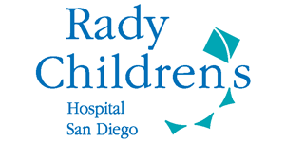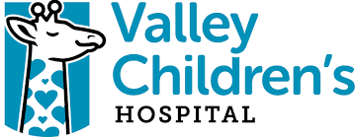

**Acknowledgements**

The creation of this document was made possible under the guidance of UCSF Benioff Children’s Hospital Oakland Perioperative Services and was modeled after the Rady Children’s Hospital San Diego Autism Discovery Institute Hospital Visit Toolkit. The content was written and designed by the University of San Francisco MSN-RN graduate students*.

The authors would like to give special thanks to the following internal and external collaborators:

**UCSF Benioff Children’s Hospital Oakland**

* Perioperative Services
  + Scout Hebinck, RN-C, MSN, Nurse Educator
  + Perioperative Staff
  + Preview Clinic Staff
  + Anesthesia Team
* Family Advisory Council
* Child Life Services
  + Hania Thomas-Adams
* Mental Health & Child Development
  + Shanti Gooden, MD
  + Monifa Willis, PMHNP-BC
* Kaizen Operations Team
  + Susan Martinez, Director
* Enterprise EHR Reporting Department
  + Mao Li, Clinical Informatics Specialist

**External Collaborators**

* Juvo Autism & Behavioral Health Services
  + Kristin Ojala, MA, BCBA
* Valley Children’s Hospital, Fresno CA
  + Tana Leon-Toscano, Peri-Op Educator

*Marissa Carapinha, Linda Gorostieta, Paige McCann, Kelsey Morton, Sabrina Young-Koli, Ian Fong, Heather Ford, Sandra Lieu, Charlene Noce, Erin Scheller, Farheen Malik, Mark Richeson, and Amy Thomas